STRUCTURAL ANALYSIS REPORT
FOR
RESIDENTIAL BUILDING OF
SABITA TIWARI
_______________
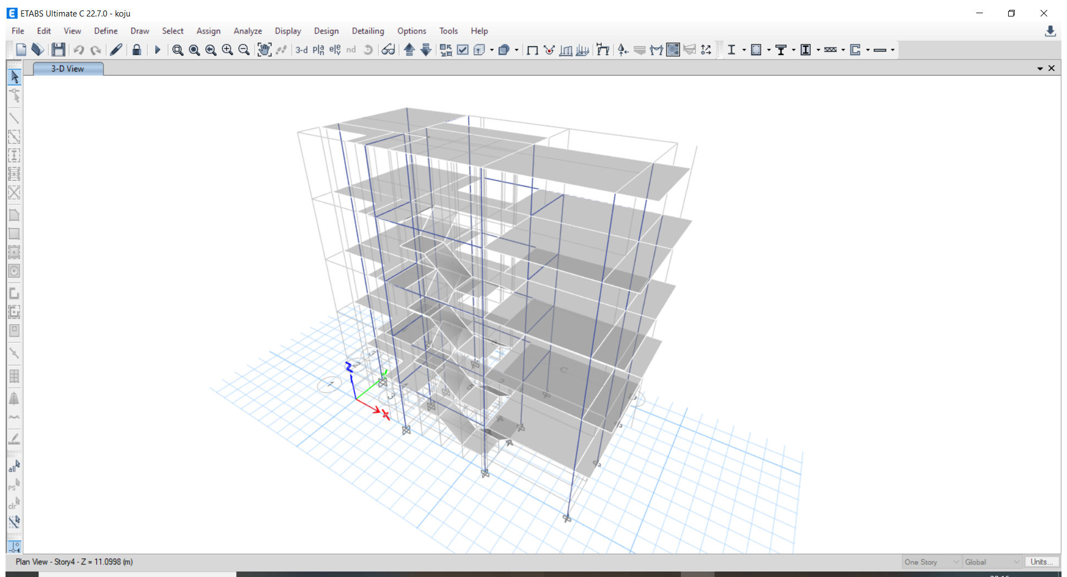

MAY 2026

SUBMITTED TO:
Mr. KRISHNA BHAKTA KOJU

Designed By:
Menaka Suwal
NEC NO.: 14037 Civil “A”

Table of Contents
LIST OF FIGURES II
LIST OF TABLES II
A Features of the Building 1
A.1 General Information of the Project 1
A.2 Element sizes 1
A.3 Structural System and Foundation 1
B Modelling of the Building 1
B.1 Material Properties (Concrete, Re-bar, Structural Steel) 1
B.2 Stiffness Modifiers 2
B.3 Slab and Diaphragm 2
B.4 Accidental Eccentricity 2
B.5 Support Condition 2
B.6 Structural Analysis Software Used 2
C Adequacy of Actions to the Buildings 2
C.1 Load Patterns considered 2
C.2 Load Cases Considered 4
C.3 Mass Source Considered for Seismic Weight 4
C.4 Periods of vibration 4
C.4.1 Empirical Equations 4
C.4.2 Amplification of Approximate Period 4
C.5 Seismic Load Calculation Parameters 4
C.5.1 Base Shear Calculation from Equivalent Static Method 4
C.6 Load Combinations 6
D Analysis of Building 6
D.1 Modal Analysis Results 6
D.2 Inter-Story Deflections 6
E STRUCTURAL IRREGULARITY 9
E.1 Vertical Irregularity 9
E.2 Plan Irregularity 9
E.3 Conclusion 9
F Adequacy of Member Design 10
F.1 Check for All Members Passed (for Element Design through Software) 10
F.2 Check for Column-Beam (C/B) Capacity Ratio 10
F.3 Design of Slabs 11
F.4 Design of Beams 12
F.5 Design of Columns 14
F.6 Check for Ductile Detailing 16
F.7 Design of Foundations 16
F.8 Design of Staircases 19

LIST OF FIGURES
Figure 1 Storey Drift: Eqx ULS 7
Figure 2 Storey Drift: Eqy ULS 7
Figure 3 Storey Drift: Eqx SLS 8
Figure 4 Storey Drift: Eqy SLS 8
Figure 5 RCC Design Check 10
Figure 6 Column - Beam Capacity Ratio 10
Figure 7 RCC Design Results: Beam Longitudinal Rebar Ground Floor 12
Figure 8 RCC Design Results: Beam Longitudinal Rebar First Floor 13
Figure 9 RCC Design Results: Beam Longitudinal Rebar Second Floor 13
Figure 10 RCC Design Results: Beam Longitudinal Rebar Third Floor 14
Figure 14 RCC Design Results: Column Longitudinal Rebar Grid A 14
Figure 15 RCC Design Results: Column Longitudinal Rebar Grid B 15
Figure 16 RCC Design Results: Column Longitudinal Rebar Grid C 15
Figure 18 Footing Settlement 16
Figure 19 Soil Pressure on Footings 16
Figure 20 Design Results: Foundation Tie Beams Longitudinal Rebars 17
Figure 21 Design Results: Footing Top Bar 17
Figure 22 Design Results: Footing Bottom Bars 18

LIST OF TABLES

Table 1 General Information of Building 1
Table 2 General Information on Structural Information of the Building 1
Table 3 Structural System and Foundations 1
Table 4 Effective Stiffness of Different Components 2
Table 5 Load Assessment for structural Analysis 3
Table 6 Live load intensity of Different Room 3
Table 7 Mass Sources for Seismic Weight 4
Table 8 Time period and Modal Mass Participation ratio 6

Features of the Building

General Information of the Project
Design Details:
The building has three floors made of reinforced concrete frames and filled with brick walls.
Table 1 General Information of Building
1 | Location of Building
2 | Number of Storeys Proposed for Building | G+4
3 | Number of Storeys Considered in Design | G+4
4 | Height of Typical Floor | 2.7432 meters
5 | Total Height of the Building super structure | 13.6906 meters
8 | Height considered for Fundamental Time Period | 13.6906 meters
9 | Occupancy Type of the Building according to the Building Code | Ordinary Structure  Residential

Element sizes
Table 2 General Information on Structural Information of the Building
Element | Description | Grade of Concrete | Remarks
Column | 355.6 mm x 355.6 mm | M25
Floor Beams | 230 mm x 355.6 mm | M25
Slab | 127 mm | M20
Foundation | Isolated footing,  Combined Footing | M20 | SBC is taken as 120 kN/m2

Structural System and Foundation
The chosen structural system for the building is a reinforced concrete (RC) building with a Special Moment Resisting Frame (SMRF). The columns and beams are carefully laid out in coordination with the architectural and services planning. This arrangement ensures that the structure can effectively support and transmit forces from earthquake motions, gravity, and live loads to the ground. The significance of this system increases as the building height increases. Hence, the key requirements for the structural systems are sufficient strength to prevent failure, adequate lateral stiffness, and efficient performance over the building's lifespan. The selection and arrangement of major structural elements to efficiently resist gravity and horizontal loads are essential in determining the building's structural form. Several factors influence the choice of structural form, including internal planning, construction materials and methods, external architectural treatment, placement and routing of service systems, magnitude and nature of horizontal loading, as well as the building's height and proportions.
All loads from the building's superstructure are transferred to the ground. If the foundation design is inadequate, all efforts put into designing the superstructure would be futile. Therefore, meticulous care must be taken in the design of foundations. The foundation design process begins with detailed field and soil investigation. Understanding the soil's geotechnical properties, including soil chemistry, is crucial to ensure the foundation performs reliably.
Table 3 Structural System and Foundations
1 | Type of Structural System | Moment Resisting Frames
2 | Type of Foundation | Isolated footing, Combined Footing
3 | Type of Slab used | Conventional

Modelling of the Building

Material Properties (Concrete, Re-bar, Structural Steel)
CONCRETE
According to NBC105:2025, The material should be taken as per Cl.2.1.
Minimum grade of structural concrete shall be M20, but M25 for buildings more than 12 m in height.
As the building is more than 12 m in height, M25 concrete has been taken for all the structural components.
STEEL
Steel reinforcement used shall be of,
a) Grade Fe 415 or less; or
b) High strength deformed steel bars produced by thermo-mechanical treatment process having elongation capacity of more than 15 percent; e.g. Grade Fe 500 and Fe 550.
Steel Grade of Fe500 has been used in the longitudinal and transverse reinforcement

Stiffness Modifiers
Table 4 Effective Stiffness of Different Components
No. | Component | Flexural Stiffness
 |  | Ultimate | Serviceability
1 | Beam | 0.35 E_{c} I_{g} | 0.70 E_{c} I_{g}
2 | Columns | 0.70 E_{c} I_{g} | 0.90 E_{c} I_{g}
3 | Wall-Cracked | 0.50 E_{c} I_{g} | 0.70 E_{c} I_{g}
4 | Wall-uncracked | 0.80 E_{c} I_{g} | 0.90 E_{c} I_{g}

Slab and Diaphragm
The column exhibits high rigidity in the vertical direction, while the floor system is assumed to have significantly higher stiffness in resisting horizontal loads, primarily due to the presence of the floor slab. The floor slab contributes to the overall in- plane rigidity, causing the columns, walls, and braces connected to that plane to behave as a cohesive unit when subjected to lateral forces. This system is commonly referred to as a rigid floor diaphragm, where the beam is seamlessly connected to the slab, resulting in minimal bending in the vertical plane. Conventional slab with rigid diaphragm has been assumed

Accidental Eccentricity
Due to the eccentricity arising between the centre of mass and the centre of rigidity at each floor level of the building, code requires increase in shear forces on the lateral force resisting elements caused by the twisting about the vertical axis of the building. Hence design codes prescribe that the actual centre of mass shall be shifted by a stipulated value to consider accidental torsional force in the lateral force resisting elements, i.e. columns and shear walls. In this part of the checklist, accidental eccentricity to be considered in x-direction as per the clause 5.6 of NBC 105:2025 is to be listed. As per the clause, the value of accidental eccentricity shall
be ±0.05*b where b is the floor lateral dimension of the building perpendicular to the direction of lateral force EQx.

Support Condition
If the building is supported by a pile or mat foundation, or an isolated footing on firm soil, the support condition is considered to be fixed. However, if the soil is less firm and the foundation type is isolated, the support condition will be closer to a hinge support. Therefore, it is necessary for the designer to specify the appropriate type of support used in the building model in this section of the checklist. For this design, the foundation is assumed to be fixed.

Structural Analysis Software Used
The building was modelled using the ETABS 22.7.0 software. ETABS 22.7.0 is a specialized program designed specifically for the analysis and design of building systems. It offers a user-friendly interface and advanced features, making it both sophisticated and easy to use. The software provides intuitive modelling capabilities, powerful analytical tools, efficient design procedures, robust numerical methods, and supports various international design codes. With its ability to handle complex structures and nonlinear behaviours, ETABS 22.7.0 is widely preferred by structural engineers in the building industry. However, finite element software like SAP2000 Staad.Pro, RISA3D, etc. are also present.

Adequacy of Actions to the Buildings

Load Patterns considered
- Dead
- 9" Wall Load
- Partition wall
- Floor Finish
- EQx ULS
- EQx SLS
- EQy ULS
- EQy SLS
- Live
- Staircase steps
- Stair live
- Water tank
Load calculations are performed using the NBC 102:1994 as a reference. The first step is to select the type of material and determine the unit weight values from the aforementioned code. The thickness of the material is chosen based on the design requirements. With the knowledge of the area, thickness, and unit weight of the materials, the loads on each section are determined.

The brick masonry is constructed with careful adherence to standard practices, including pre-soaking the bricks in water, ensuring level bedding with full mortar coverage, breaking vertical joints from course to course, and filling them with mortar completely.
Bricks: Standard rectangular bricks are used, which are well burnt, hand-formed or machine-made, and possess a crushing strength of at least 3.5 N/mm². The preferred brick size is 230 x 115 x 57 mm, with 10 mm thick horizontal and vertical mortar joints.
Tolerances: For thick walls, acceptable tolerances are -10 mm on length, -5 mm on width, and ±3 mm on thickness.
Wall Thickness: The minimum thickness is half-brick, while the maximum thickness is one brick.
Mortar: Cement-sand mixes of 1:6 and 1:4 are adopted for one-brick and half-brick thick walls, respectively. Adding a small amount of freshly hydrated lime, in a ratio of ¼ to ½ of the cement, enhances the mortar's plasticity without compromising its strength. Therefore, adding lime within these limits is encouraged.
Plaster: All plasters should have a cement-sand mix with a minimum ratio of 1:6 and a cube crushing strength of at least 3 N/mm² after 28 days.
Wall Thicknesses: Internal walls have a thickness of up to 115 mm for brick walls or equivalent materials, while external walls have a thickness of up to 230 mm for brick walls or equivalent materials.

Table 5 Load Assessment for structural Analysis
1 | Unit Weights of materials
 | Brick Masonry | 19.2 | kN/m3
 | Screed | 20 | kN/m3
 | Reinforced Concrete | 25 | kN/m3
 | Cement Plaster | 20 | kN/m3
2 | Height of Beams, walls and parapet Walls
 | Height of Parapet Wall | 1.0668 | m
 | Wall Thickness | 0.23 | m
 | Plaster Thickness | 12.5 | mm
3 | Dead Loads of Walls
 | Dead load of 230mm thick wall without opening and height upto beam | 10.544 | kN/m
 | Dead load of 230mm thick wall without opening and height upto ceiling of slab | 11.55 | kN/m
 | Dead load of 230mm thick wall with 30% opening and height upto beam | 7.381 | kN/m
 | Dead load of 230mm thick wall with 30% opening and height upto ceiling of slab | 8.087 | kN/m
 | Dead load of 115mm thick wall without opening and height upto beam | 5.272 | kN/m
 | Dead load of 115mm thick wall without opening and height upto ceiling of slab | 5.78 | kN/m
 | Dead load of 115mm thick wall with 30% opening and height upto beam | 3.69 | kN/m
 | Dead load of 115mm thick wall with 30% opening and height upto ceiling of slab | 4.044 | kN/m
 | Dead load of Parapet wall | 2.356 | kN/m

The live loads for the floor and roof are determined using IS 875 part 2, as referenced by the National Building Code. For residential buildings, the appropriate live load values specified in Table 1 of IS 875 Part 2 are considered. Since the building is intended for residential use, the loading intensity for dwelling houses under the
residential category is taken into account.
Table 6 Live load intensity of Different Room
S.N. | Occupancy Classification | Uniformly Distributed Load
 | Dwelling Houses
1 | All rooms and kitchens | 2.0 kN/m2
2 | Toilet and bath rooms | 2.0 kN/m2
3 | Corridors, passages, staircases | 3.0 kN/m2
4 | Balconies | 3.0 kN/m2
5 | Flat sloping or curved roof with slopes up to and including 10 degrees
 | Access provided | 1.5 kN/m2
 | Access not provided except for maintenances | 0.75 kN/m2

Load Cases Considered
- Dead
- Live
- Modal
- EQx ULS
- EQx SLS
- EQy ULS
- EQy SLS

Mass Source Considered for Seismic Weight
Table 7 Mass Sources for Seismic Weight
Load | Multiplier
Live<3 kN/m² | 0.25
Live>=3 kN/m² | 0.5
Dead Loads ( Self weight, walls, floor finishes etc) | 1

Periods of vibration
The fundamental time period shall be determined using following methods:

Empirical Equations
$$T_{1}=k_{t}H^{\frac{3}{4}}$$
Here,
kt = 0.075
H = Height of the building from foundation or from top of a rigid basement = 13.6906 m
T1 = 0.667 s

Amplification of Approximate Period
The approximate fundamental time period calculated using empirical equation in section 5 1.2 shall be increased by a factor of 1.25.
Amplified Approximate Fundamental time period =0.83375 s

Seismic Load Calculation Parameters

Base Shear Calculation from Equivalent Static Method
Elastic Site Spectra for horizontal loading is given by C(T)=C_{h}(T)*Z*I as per cl 4.1(1)
Where,
C_{h}(T)=Spectral Shape factor as per cl.4.1.2
Z= Seismic Zoning Factor as per 4.1.4
I=Importance factor as per 4.1.5

Spectral Shape Factor, C_{h} (T)
Fundamental Time Period = | 0.83375 s
Site Soil Category = | Very Soft Soil 'D'
T_{a} = | 0
T_{c} = | 2
Soil Type = | D
α = | 2.25
k = | 0.8
𝐶_{ℎ}(𝑇)= | 1+(α-1)x(T/T_{a}) | if T<T_{a}
 | α  (αxT_{c)}/T | if T_{a}≤T≤T_{c}  if T_{c}≤T≤T_{d}
 | (αxT_{d} xT_{c} )/ T2 | if T_{d}≤T≤6
Spectral Shape Factor C_{h}(T)= 2.25

Seismic Zoning Factor (Z)
Location= | Bhaktapur
PGA (Z)= | 0.35
Structural Types = | Ordinary Structures
Importance Factor = | 1
Elastic Site Spectra for Horizontal loading C(T) =C_{h}(T)*Z*I =0.7875
Elastic Site Spectra for Serviceability limit state, C_{s}(T) = 0.20 C (T) =0.1575

Horizontal base shear coefficient
$$Ultimate Limit State C_{d}\left(T_{1}\right)=\frac{C(T_{1})}{R_{μ}×Ω_{u}}$$
Where,
C (T₁) = Elastic Site Spectra as per 4.1.1
Rμ = Ductility Factor as per 5.3.2
𝛀u = Over strength Factor for ULS as per 5.4
$$Serviceability Limit State C_{d}\left(T_{1}\right)=\frac{Cs(T_{1})}{Ω_{s}}$$
Where,
C_{s}(T₁) = Elastic Site Spectra determined for Serviceability Limit State as per 4.2
𝛀s = Over strength Factor for SLS as per 5.4

C(T) = | 0.7875
C_{s}(T)= | 0.1575
Structural System = | Reinforced Concrete Moment Resisting Frame
Ductility Factor Rμ = | 4
Over strength Factor Ultimate limit State Ωu = | 1.5
Over strength Factor Serviceability limit State Ωs= | 1.25
C_{d}(𝑇₁)=C(𝑇1)/R_{μ} x Ω_{u} | 0.1313
C_{d}(T₁)=C_{s}(T1)/ Ω_{s} | 0.126

Horizontal seismic base shear
V = C_{d} (T₁) W
Where,
C_{d} (T₁) = Horizontal base shear coefficient as per 6.1
W = Seismic Weight of the structure as per 5.2

Vertical distribution of seismic forces
$$F_{i}=\frac{W_{i}h_{i}^{k}}{\sum_{i}^{n}{W_{i}h_{i}^{k}}}×V$$
Where,
Wi = seismic weight of the structure assigned to level ‘i’;
hi= height (m) from the base to level ‘i’;
n= total number of floors/levels
V= horizontal seismic base shear calculated as per 6.2
k= an exponent related to the structural period
for structure having time period T≤0.5sec, k=1
for structure having time period T≥2.5sec, k=2
for structure having period between 0.5 sec and 2.5 sec, k shall be determined by linear interpolation between 1 and 2.

k = 1.0835

Load Combinations
When lateral load resisting elements are oriented along mutually orthogonal horizontal directions, the structure system is considered to be non-parallel and load combinations as specified in clause 3.6.2 of NBC 105:2025 is used for design.
- 1.2DL + 1.5LL  - 0.9 DL +Ex  - 0.9 DL -Ex  - 0.9 DL +Ey  - 0.9 DL -Ey | - DL+0.3 LL +Ex  - DL+0.3 LL -Ex  - DL+0.3 LL +Ey  - DL+0.3 LL -Ey

Analysis of Building

Modal Analysis Results
NBC105:2025 clause 7.3 states that number of modes to be used in the analysis should be such that the sum total of modal masses of all modes considered is at least 90 percent of the total seismic mass of the structure. The analysis was carried out for 12 modes so that the mass participation satisfies this criterion in both orthogonal directions. The table shows time period and mass participation ratio for all modes.
Table 8 Time period and Modal Mass Participation ratio
Case | Mode | Period(Sec) | UX | UY | SumUX | SumUY
Modal | 1 | 0.982 | 0.7853 | 0.001 | 0.7853 | 0.001
Modal | 2 | 0.855 | 0.0129 | 0.6911 | 0.7981 | 0.692
Modal | 3 | 0.826 | 0.0297 | 0.1495 | 0.8278 | 0.8415
Modal | 4 | 0.305 | 0.1027 | 0.0002 | 0.9305 | 0.8417
Modal | 5 | 0.274 | 0.0016 | 0.077 | 0.9322 | 0.9187
Modal | 6 | 0.261 | 0.002 | 0.0244 | 0.9341 | 0.9431
Modal | 7 | 0.165 | 0.0401 | 0.0002 | 0.9742 | 0.9433
Modal | 8 | 0.158 | 0.0008 | 0.0224 | 0.975 | 0.9657
Modal | 9 | 0.144 | 0.0001 | 0.0134 | 0.9751 | 0.9791
Modal | 10 | 0.112 | 0 | 0.0095 | 0.9751 | 0.9886
Modal | 11 | 0.11 | 0.0182 | 7.55E-07 | 0.9933 | 0.9886
Modal | 12 | 0.098 | 0 | 0.0063 | 0.9933 | 0.9949

Inter-Story Deflections
The ratio of the inter-story deflection to the corresponding story height shall not exceed:
0.025 at ultimate limit state
0.006 at serviceability limit state

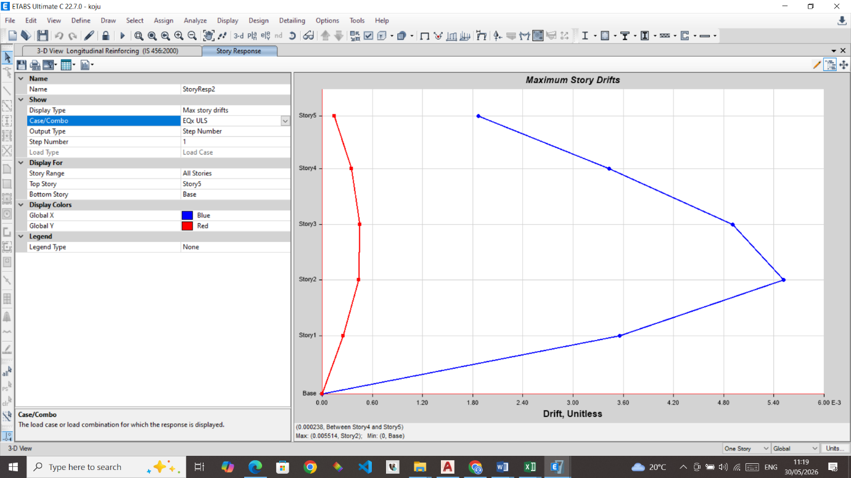
Figure 1 Storey Drift: Eqx ULS

Design horizontal Inter-Story Drift = 0.005514 x 2.7432 = 0.015126< 0.025, OK

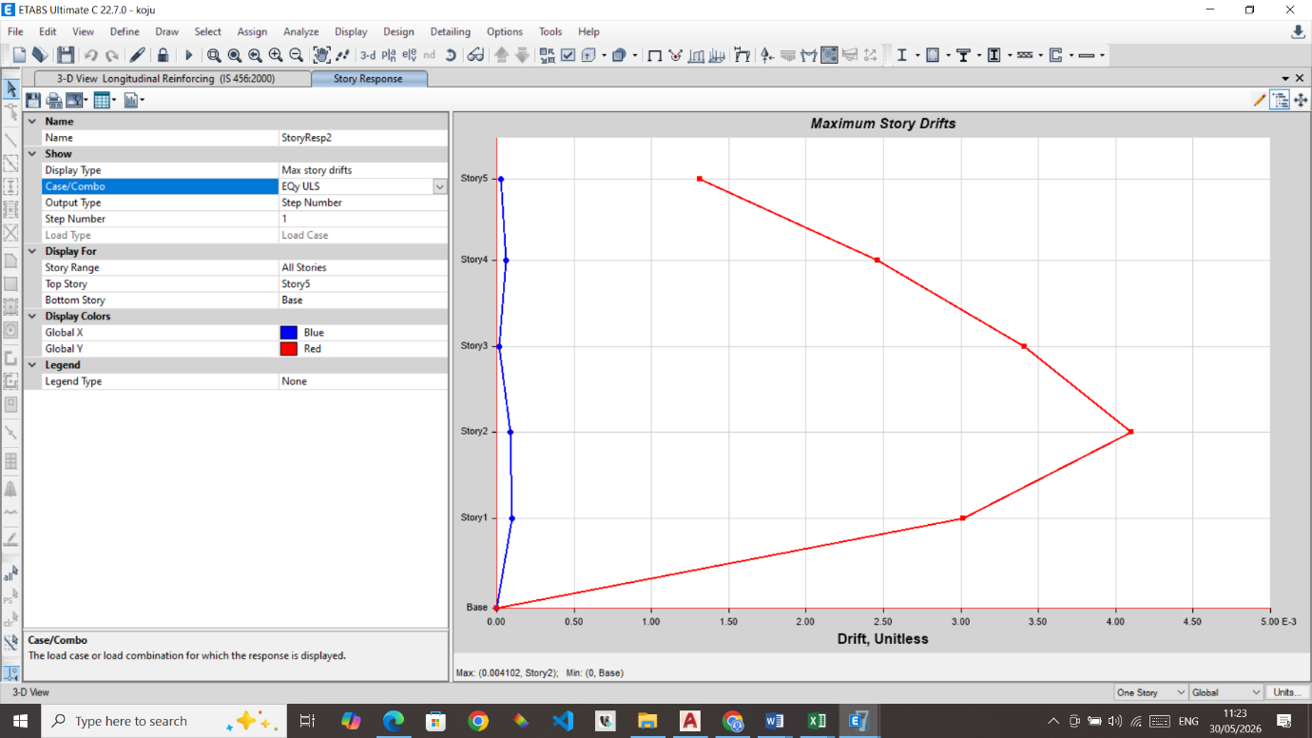
Figure 2 Storey Drift: Eqy ULS

Design horizontal Inter-Story Drift = 0.004102 x 2.7432 = 0.011253 < 0.025, OK

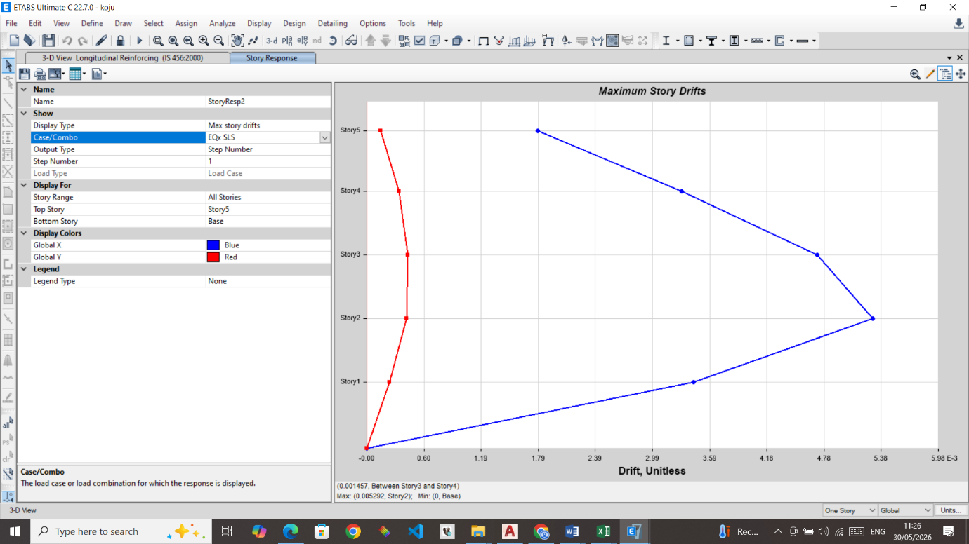

Figure 3 Storey Drift: Eqx SLS

Design horizontal Inter-Story Drift = 0.005292 < 0.006, OK (For SLS)

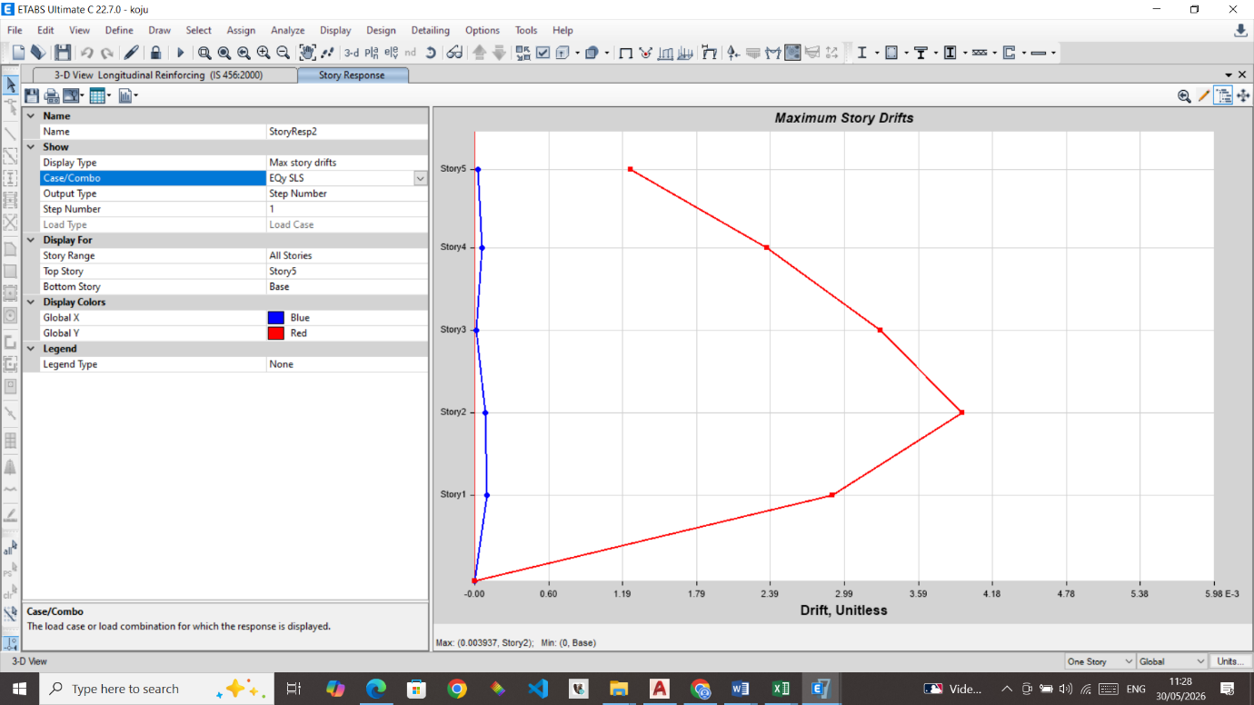
Figure 4 Storey Drift: Eqy SLS
Design horizontal Inter-Story Drift = 0.003937 < 0.006, OK (For SLS)

STRUCTURAL IRREGULARITY
One of the basic virtues of earthquake resistant design of structures is that the structure shall be regular as much as possible. It is observed that the structures with simple and regular configurations suffer much less damage during a large earthquake in comparison to the structures with irregular configurations. At the planning stage itself, the Designer should try to make the structure as regular as possible. Clause 5.4 of NBC 105:2025 has given provisions to check the structural irregularity of structures.

Vertical Irregularity
- Weak Storey: A storey is considered weak if the lateral strength is less than 80% of that of the storey above — Not observed.
- Soft Storey: A storey is soft if its stiffness is less than 70% of the storey above or less than 80% of the average stiffness of the three storeys above — Not observed.
- Vertical Geometric Irregularity: Occurs when the horizontal dimension of the lateral force-resisting system in any storey exceeds 130% of that in an adjacent storey — Not observed.
- In-plane Discontinuity: Exists when vertical lateral force-resisting elements are offset in plane — Not observed.
- Mass Irregularity: Occurs if the effective mass differs by more than 50% from the adjacent storey — Not observed.

Plan Irregularity
- Torsional Irregularity: When maximum displacement at one end exceeds 1.5× the minimum at the other end — Not observed.
- Extreme Torsional Irregularity: Maximum displacement exceeds 2.5× minimum (not permitted) — Not observed.
- Re-entrant Corners: Projection exceeds 15% of overall dimension — Not observed.
- Diaphragm Discontinuity: Openings >50% or stiffness variation >50% between storeys — Not observed.
- Out-of-plane Offset: Discontinuity in vertical lateral force-resisting elements — Not observed.

Conclusion

No vertical or plan irregularities were identified. The building is regular and complies with NBC 105:2025 for earthquake-resistant design.

Adequacy of Member Design

Check for All Members Passed (for Element Design through Software)

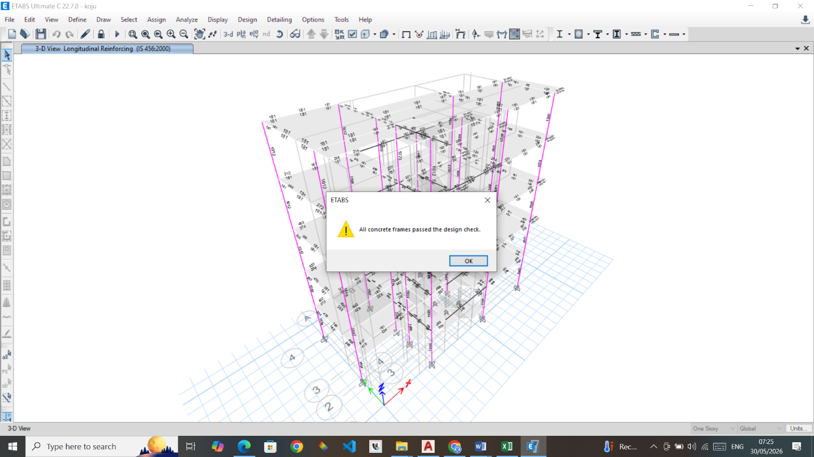
Figure 5 RCC Design Check

Check for Column-Beam (C/B) Capacity Ratio

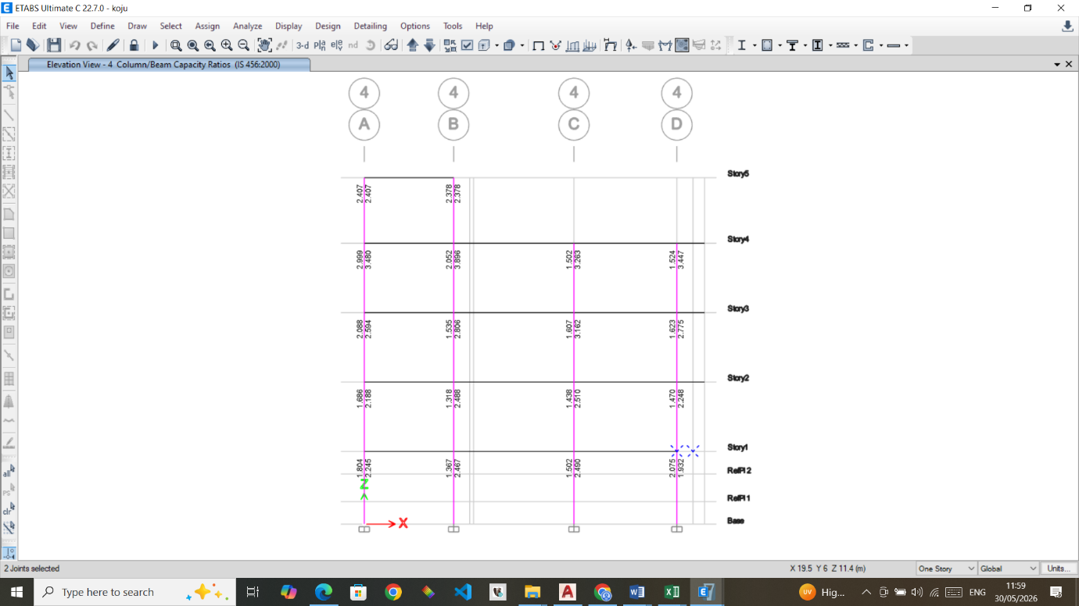
Figure 6 Column - Beam Capacity Ratio

To prevent the progressive collapse of a structure caused by the failure of columns at lower levels, the design follows the principle of Strong-Column-Weak Beam Design. This design approach ensures that the columns are designed to be stronger than the beams. This helps the structure effectively absorb and dissipate seismic energy, reducing the risk of complete collapse. By allowing plastic hinges to form in the beams, the structure gains increased ductility, enabling it to undergo significant lateral displacements while maintaining its integrity. This design strategy enhances the structure's ability to withstand seismic forces and mitigate potential damage.

Design of Slabs
Slab are designed as per IS 456 code.

Length of shorter span (lx) = |  |  |  | 3.66 | m
Length of longer span (ly) = |  |  |  | 4.22 | m
Support condition |  |  |  | 4
Slab type
 |  |  | α = | 20
 |  |  | β = | 1
γ (assumed) = |  |  |  | 1.4
ly/lx = |  |  |  | 1.15
Design two way slab
Assume grade of concrete (fck) = |  |  |  | M | 20
Assume steel (fy) = |  |  |  | Fe | 500
Thickness of finishing = |  |  |  | 3.00 | mm
Thickness of screed = |  |  |  | 50.00 | mm
Thickness of plaster = |  |  |  | 12.50 | mm
Unit weight of finishing = |  |  |  | 21.00 | KN/m³
Unit weight of screed = |  |  |  | 23.00 | KN/m³
Unit weight of plaster = |  |  |  | 20.40 | KN/m³
Unit weight of concrete = |  |  |  | 25.00 | KN/m³
Live load = |  |  |  | 2 | KN/m²
Assume bar diameter = |  |  |  | 8.00 | mm
Effective depth of slab (d)  |  |  |  | 130.71 | mm
Assume, d = |  |  |  | 127.00 | mm
Total depth of slab, D = |  |  |  | 151.00 | mm
Dead load calculation of slab
Dead load of slab due to concrete = |  |  |  | 3.78 | KN/m²
Dead load due to floor finish Tile = |  |  |  | 0.06 | KN/m²
Dead load due to screed = |  |  |  | 1.15 | KN/m²
Dead load due to plaster = |  |  |  | 0.26 | KN/m²
Partition load = |  |  |  | 0.00 | KN/m²
Total dead load = |  |  |  | 5.24 | KN/m²
Dead load + Live load = |  |  |  | 7.24 | KN/m²
Design load = |  |  |  | 10.86 | KN/m²
Bending moment Coefficients |  |  | Max. bending moment
α_{x} = | 0.0427 |  | M_{x} = | 6.21 | KNm
−α_{x} = | 0.0567 |  | -M_{x} = | 8.25 | KNm
α_{y} = | 0.0350 |  | M_{y} = | 6.77 | KNm
−α_{y} = | 0.0470 |  | -M_{y} = | 9.09 | KNm
 |  |  | M_{max} = | 9.09 | KNm
Check depth for moment
Required depth for moment = |  |  |  | 57.40 | mm
Provided depth, d = |  |  |  | 127.00 | mm
Required depth is |  | < | Provided depth
O.K. safe
Area of steel
Solving quadratic equation
0.025 | Ast² + | -127.00 | Ast + | 15567.30 | = 0
0.025 | Ast² + | -127.00 | Ast + | 20904.67 | = 0
Bottom bars |  |  | Top bars
Ast = | 4954.31 | mm² | Ast = | 4909.69 | mm²
Ast = | 125.69 | mm² | Ast = | 170.31 | mm²
Spacing required
8 | φ rods @ | 399.7 | mm c/c | Bottom bars
8 | φ rods @ | 294.99 | mm c/c | Top bars
Spacing provided
8 | φ rods @ | 150.0 | mm c/c | Bottom bars
8 | φ rods @ | 150.0 | mm c/c | Top bars
Check for shear
Provided Ast = |  | 334.93 | mm²
p% = |  | 0.26 | k = | 1.3
 | τ_{c}' = | 0.37 | N/mm² | IS 456:2000 (Table 19)
 | τ_{c} = | 0.48 | N/mm²
Max.shear force (V_{u}) = |  | 19.88 | KN
 | τ_{v} = | 0.16 | N/mm²
 | τ_{c} | > | τ_{v}
 |  | O.K. safe
Check for minimum steel
Minimum steel (0.12%) |  |  | Provided steel
152.40 | mm² | < | 334.93 | mm²
 | O.K.

Design of Beams
Beam Design is done by Etabs using the IS 456 code.

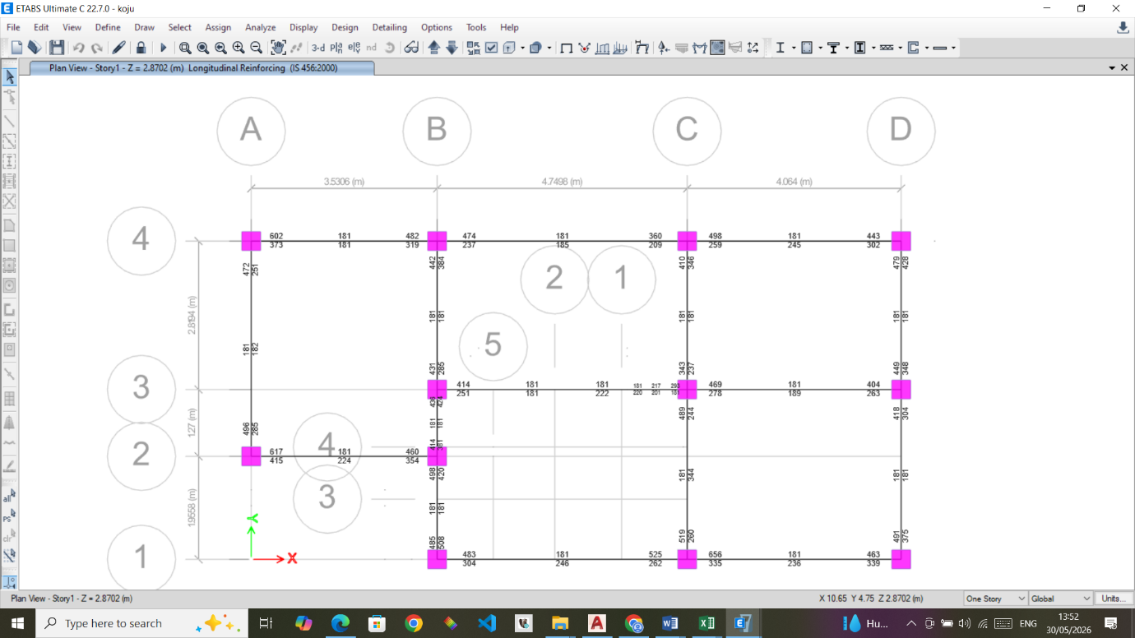
Figure 7 RCC Design Results: Beam Longitudinal Rebar First Floor

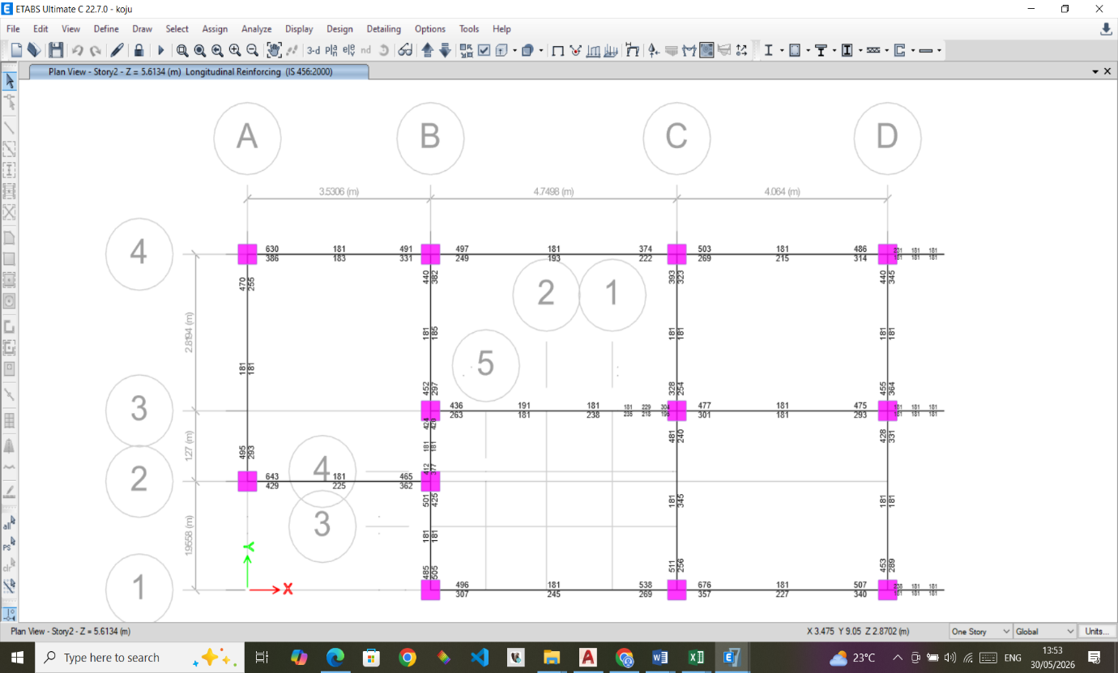
Figure 8 RCC Design Results: Beam Longitudinal Rebar Second Floor
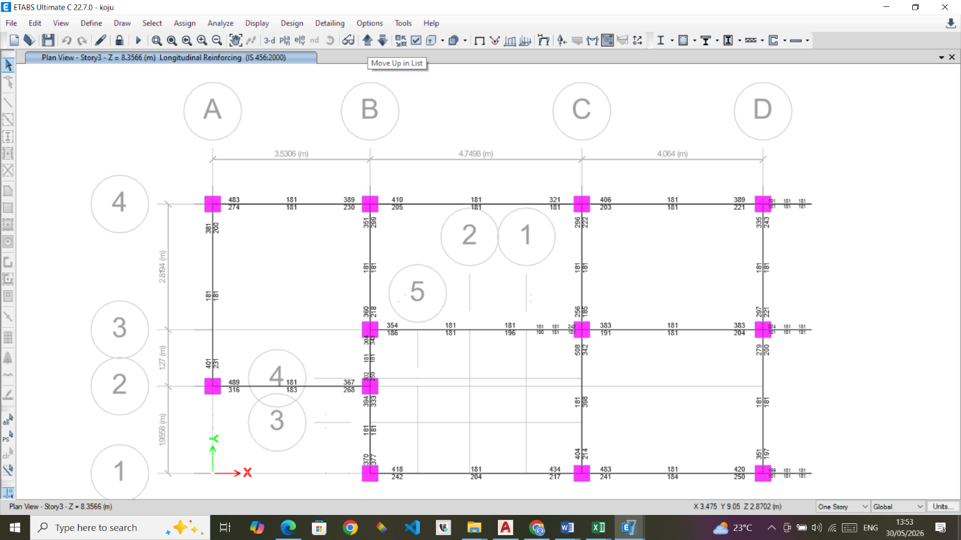
Figure 9 RCC Design Results: Beam Longitudinal Rebar Third Floor

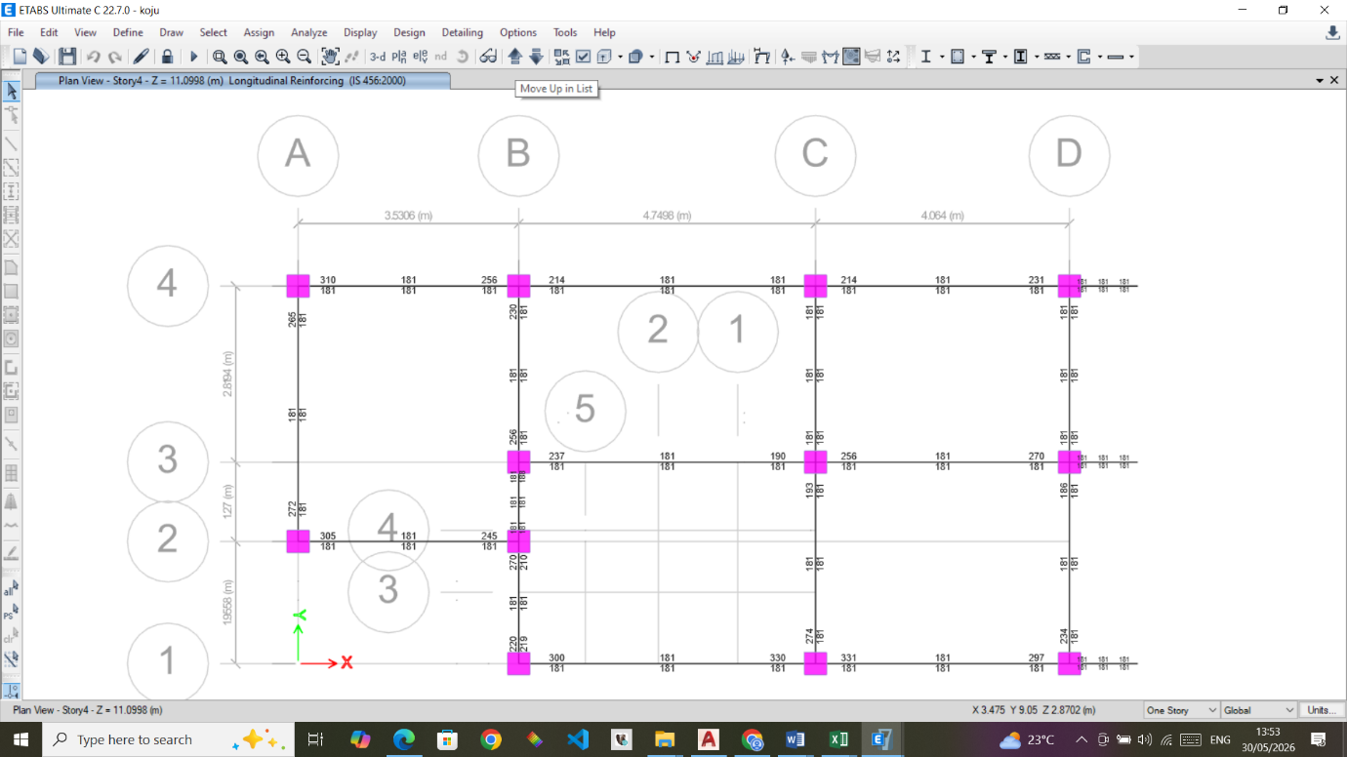

Figure 10 RCC Design Results: Beam Longitudinal Rebar Fourth Floor

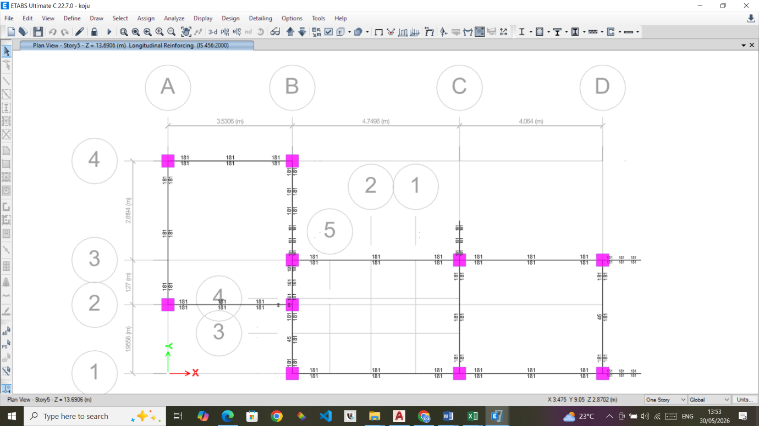
Figure 10 RCC Design Results: Beam Longitudinal Rebar Fourth Floor

Design of Columns
Column Design is done by Etabs using the IS 456 code.

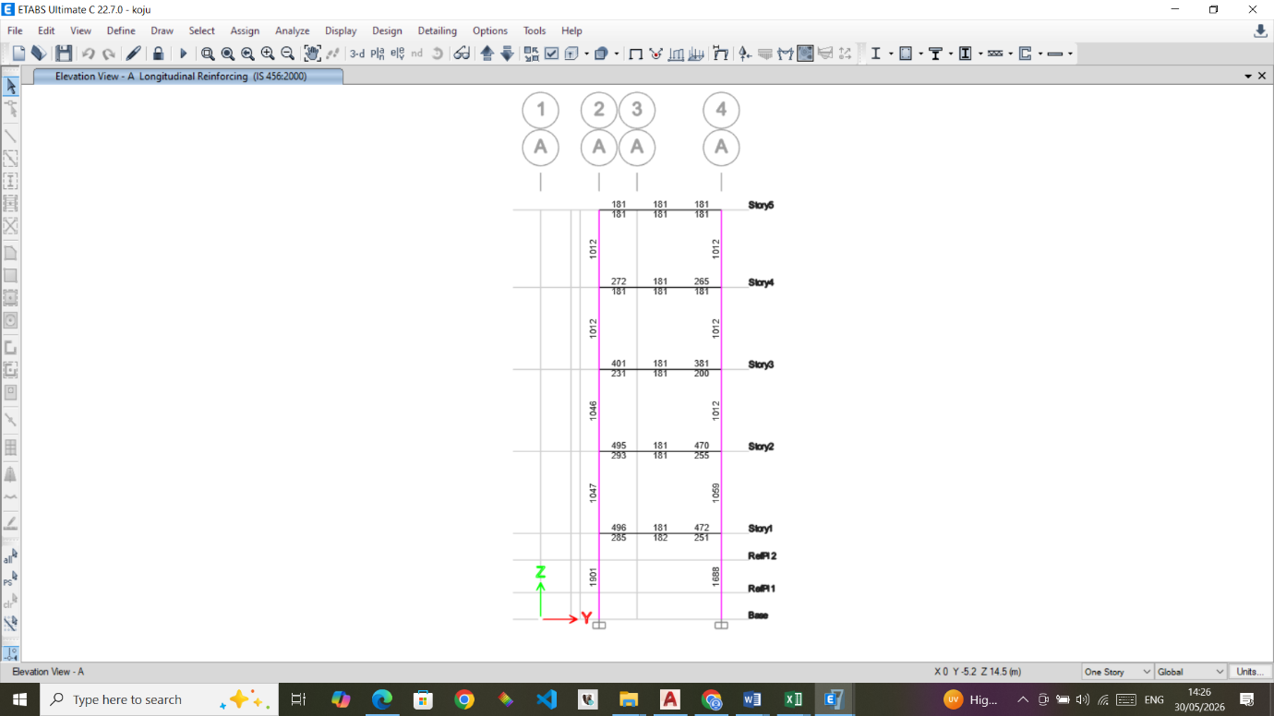
Figure 14 RCC Design Results: Column Longitudinal Rebar Grid A

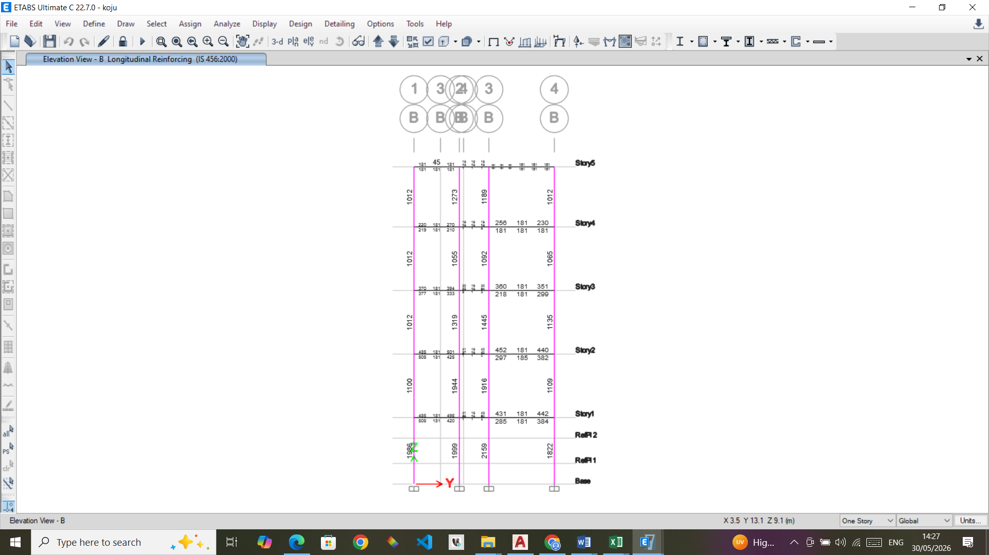
Figure 15 RCC Design Results: Column Longitudinal Rebar Grid B

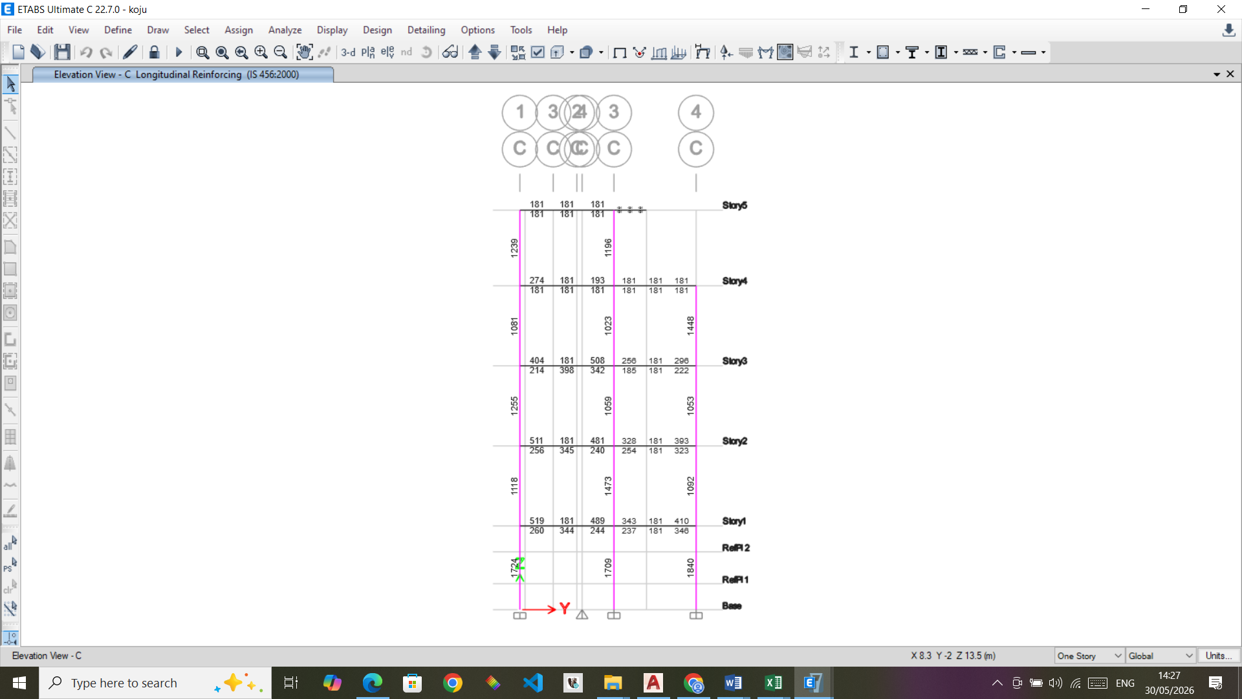
Figure 16 RCC Design Results: Column Longitudinal Rebar Grid C

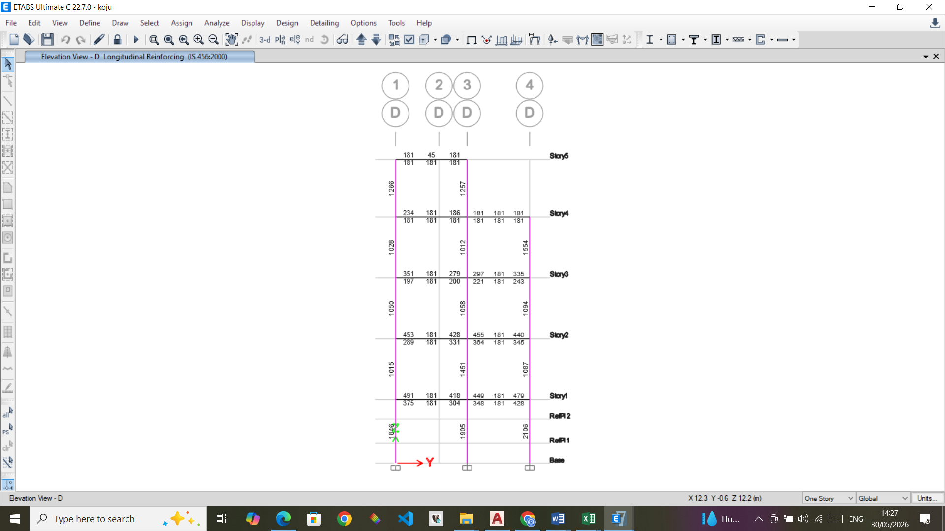
Figure 17 RCC Design Results: Column Longitudinal Rebar Grid D

Check for Ductile Detailing
Refer to the structural drawing to verify whether proper ductile detailing has been done in the beam, column, joints etc. Verify the other requirements and also the ductile detailing requirements of the building as per Annex A of the code

Design of Foundations
The foundations are designed using SAFE 22.3.0.
SBC taken 120 kN/m2, K= 14400
Maximum displacement =15.6mm < 25 mm ok
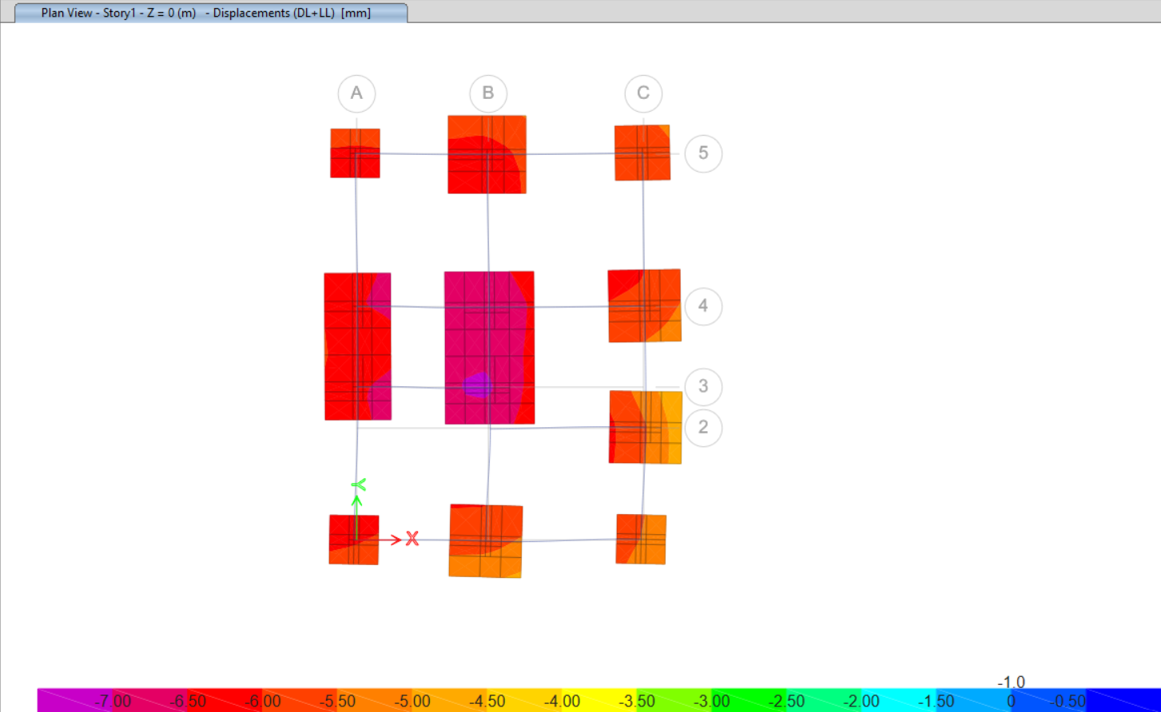
Figure 18 Footing Settlement

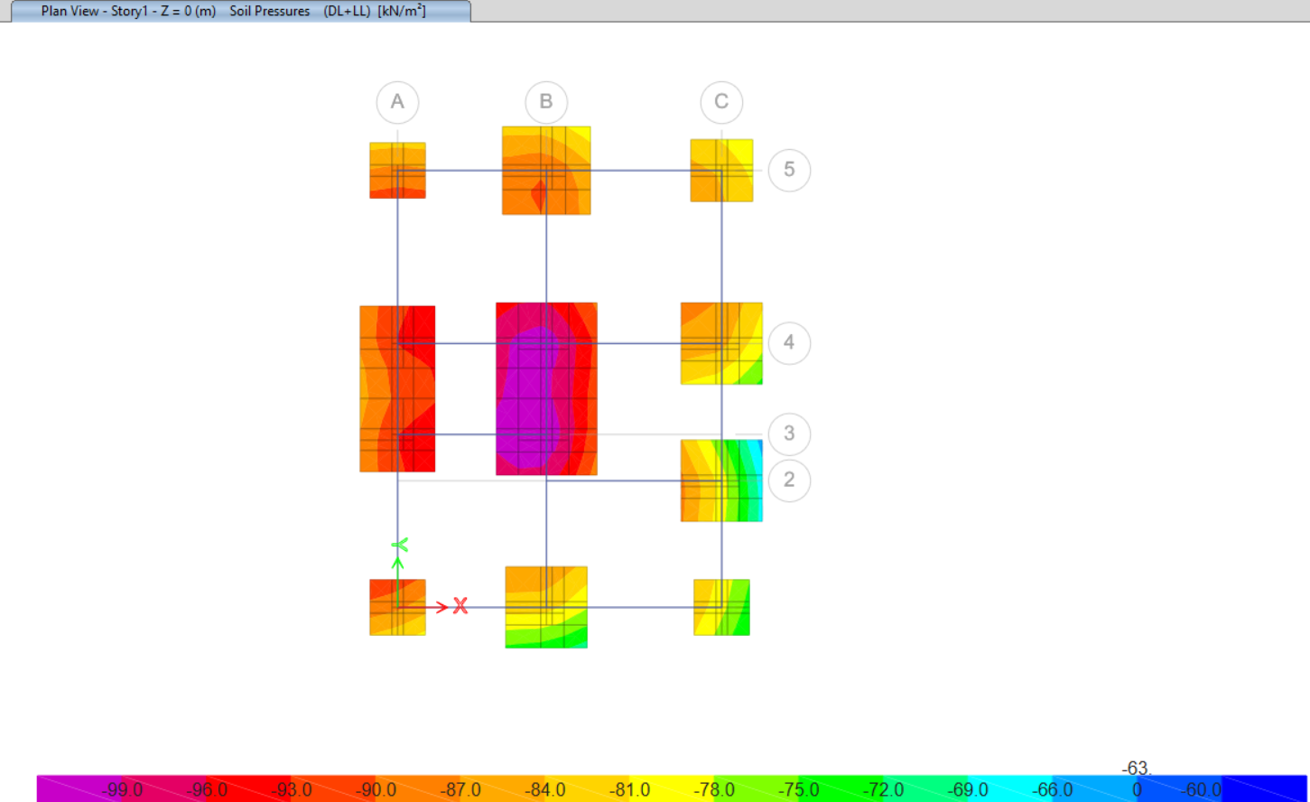
Figure 19 Soil Pressure on Footings
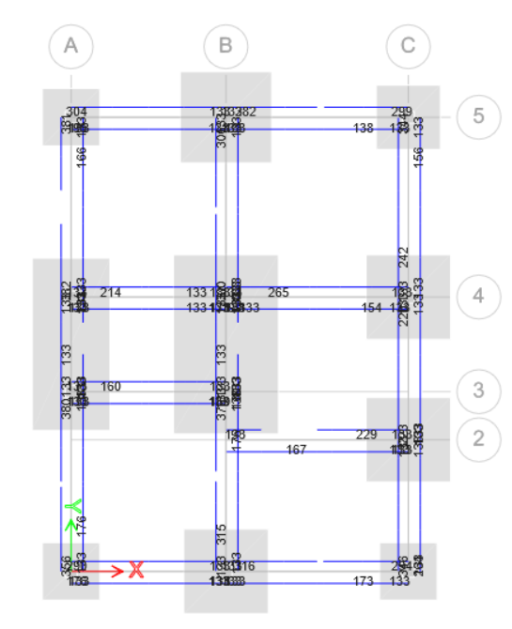
Figure 20 Design Results: Foundation Tie Beams Longitudinal Rebars

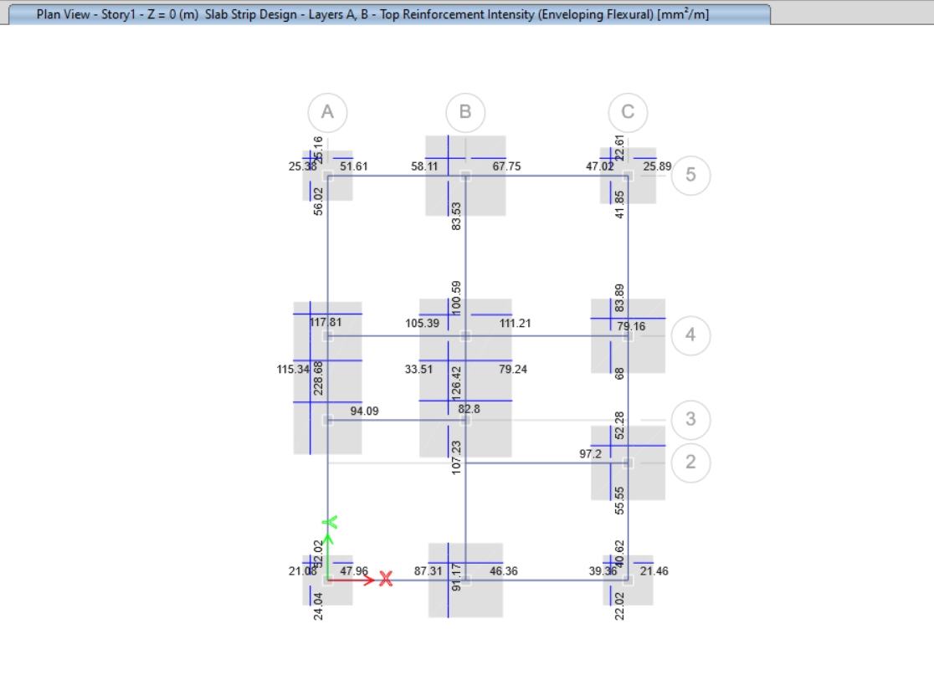
Figure 21 Design Results: Footing Top Bar

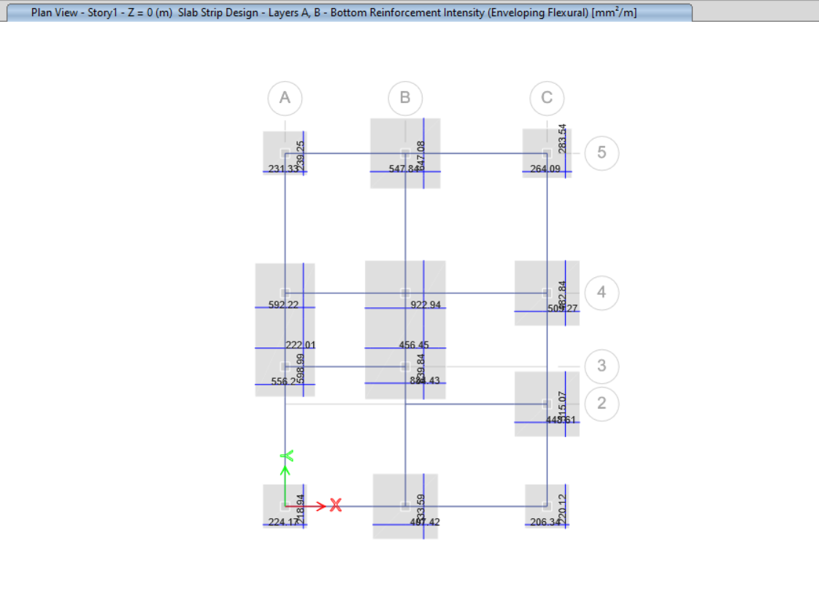
Figure 22 Design Results: Footing Bottom Bars
Footing Slab thickness= 400mm
Footing at Grid | Type | Size | Depth | Bottom Rebar | Top Rebar
A1 | Isolated | 1700x1700 | 400 | 12 dia at 150mm spacing bothways
A3,A4 | Combined | 2300x5100 | 400 | 12 dia at 150mm spacing bothways | 8 dia at 150mm spacing bothways
A5 | Isolated | 1700x1700 | 400 | 12 dia at 150mm spacing bothways
B1 | Isolated | 2500x2500 | 400 | 12 dia at 150mm spacing bothways
B3,B4 | Combined | 3100x5300 | 400 | 12 dia at 125mm spacing bothways | 8 dia at 150mm spacing bothways
B5 | Isolated | 2700x2700 | 400 | 12 dia at 150mm spacing bothways
C1 | Isolated | 1700x1700 | 400 | 12 dia at 150mm spacing bothways
C2 | Isolated | 2500x2500 | 400 | 12 dia at 150mm spacing bothways
C4 | Isolated | 2500x2500 | 400 | 12 dia at 150mm spacing bothways
C5 | Isolated | 1900x1900 | 400 | 12 dia at 150mm spacing bothways

Design of Staircases
Staircase is designed as per IS 456 slab design.
Concrete
Grade | M-20
fck(N/mm2) | 20
Steel
fu(N/mm2) | 500
Width of Flight | 1.200
Landing Width | left | Right
 | 1.2 | 1.2
Riser | 0.166
Tread | 0.279
No of Treads | 10
Support Beam Width | 0.250
Load Calculation
Effective span | 5.19
width of flight | 2.79
Waist Slab depth | 0.150
effective depth | 0.112
sloping waist length for one tread | 0.325
load on flight
Self weight of waist slab(kN/m2) | 4.364
Self weight of steps(kN/m2) | 2.075
Floor finish(kN/m2) | 1.500
Live load(kN/m2) | 3.000
total | 10.939
load on landing
Self weight of slab(kN/m2) | 3.750
Floor finish(kN/m2) | 1.500
Live load(kN/m2) | 3.000
total | 8.250
BM Calculation
R1 | 25.159
R2 | 25.159
point of max BM | 2.595
Max BM | 34.895
Ast required | 851.894
Provide bar diameter of | 12.000 | mm
spacing | 150.000 | mm
Ast provided | 904.779 | ok
Distribution bar of diameter | 10.000 | mm
Ast required(mm2) | 180.000
Spacing | 150.000 | mm
Ast provided | 523.599

